Cc

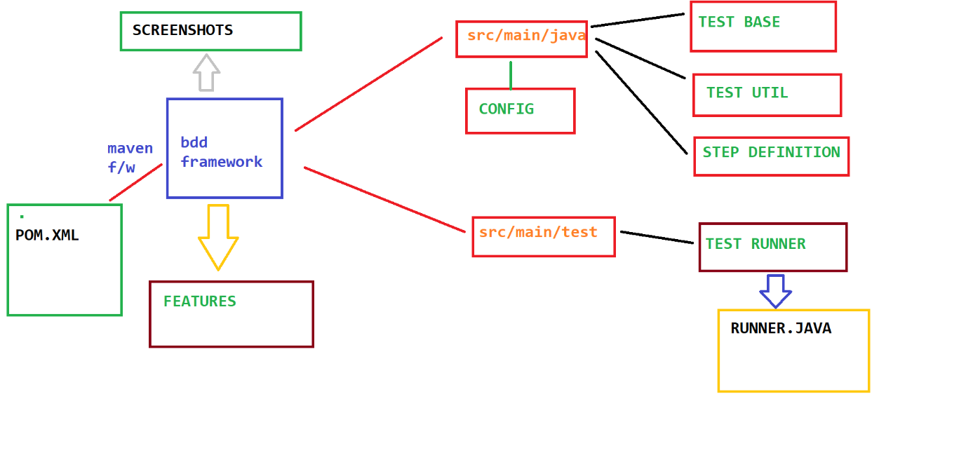

CREATE MAVEN PROJECT AND ADD CUCUMBER JARS IN POM.XML

CUCUMBER-JVM

CUCUMBER -JAVA

JUNIT

CREATE FOLDER FEATURES AT PROJECT LEVEL

CREATE FOLLOWING PACKAGES

IN MAIN JAVA

TEST BASE

TEST UTIL

CONFIG

PAGES

IN TEST JAVA

TEST RUNNER

ROUGH

TEST BASE

Here create a testbase class

This class defines the launching of browser code and navigating

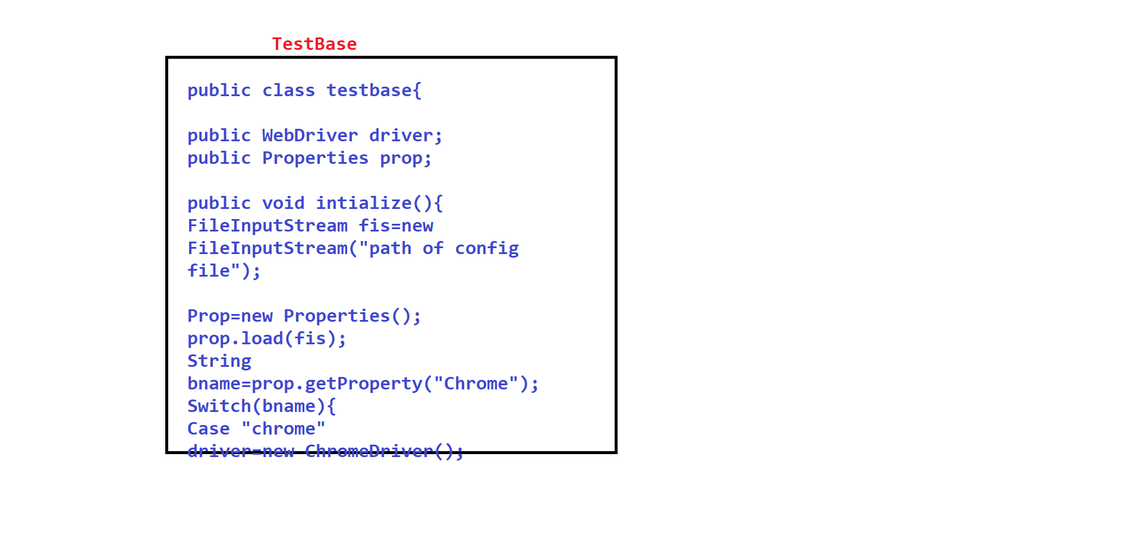

In Test Util we will have reusable methods like

Date function

Screenshot

RandomNumber

RandomString

Create a package pages

Here capture WebElements page wise

